Ghost Wood

DES508 - Game Design Document

Contents
The Brief 3
Game Delivery and Platform Scope 3
Game Overview 3
Game Concept 3
Genre 3
Target Audience 3
Game Flow Summary 3
Look and Feel 3
Gameplay and Structure 3
Gameplay 3
Game Progression 4
Level Structure 4
Objectives 4
Mechanics 4
Physics 4
Movement in the game 5
Objects 5
Screen Flow 5
Game Options 5
Replay-ability 5
Story, Setting and Characters 5
Story and Narrative 5
Presentation: 5
Story Synopsis: 5
Narrative Structure to players: 6
Game world 6
Levels 6
Levels (Blue, orange, red and black) 6
Interface 8
Visual System 8
Control System 8
Audio, music and sound effects 8
4 types of ghosts 8
Bibliography 9

The Brief
The brief relates to the term ‘Forever’ which was divided into a concept of afterlife, a realm/world where spirits reside in.

Game Delivery and Platform Scope
The intended platform is PC, made in unity and controls will be keyboard and mouse as it is readily available and easy to access.
Game length is between 5 and 10 minutes of gameplay involving all puzzles and visual novel aspect.

Game Overview

Game Concept
The player is known as ‘Moss’, a young psychic medium who lost his parents at a very young age and now helps ghosts, spirits pass through to the afterlife. The ghosts provide Moss with a series of tasks and puzzles so that he may finish them and help them pass over. There is multiple level of difficulties in ghosts, blue, orange, red and there lies how difficult each puzzle would be for Moss. Once Moss has helped the ghosts, he will unlock items such as a charm that will aid him to complete other puzzles.

Genre
A 2d Role-playing game with visual novel elements.

Target Audience
Target audience would be young adults who play 2d games with visual novel elements. Age 12+ is recommended.

Game Flow Summary
The player will start the game with a background of the story through animations and make their way into the forest where they will encounter different ghosts allowing them to go through a series of challenges in the form of puzzles that will allow for game progression through rewards over time. Thus, reaching the lost souls which will narrow down the story of the player.

Look and Feel
The basic look of the game is 2d puzzle platformer with visual novel elements. The feel of the game is influenced by the platformer Limbo (Playdead, 2011) as it gives a spooky puzzle vibe in a forest setting and the theme of the game is influenced by SpiritFarer (Thunder lotus Games, 2020) as the player transports deceased spirits to the afterlife.

Gameplay and Structure

Gameplay
The gameplay consists of 2D platforming with a set of abilities are unlocked as the player progresses through different ghosts.
The abilities consist of walking, jumping, double jumping and shooting projectiles (unlock in black ghost).
The player will use these abilities to finish puzzles asked by ghosts, as they move forward, it will get harder.

Game Progression
The game begins in a simple menu screen with the game Title ‘Ghost Wood’ and the options of ‘Start’, ‘Setting’ or ‘Quit’. After choosing to start the game the player is presented with the backstory of the player through animations and later ends up in the setting of a Forest based level. The top left side of the screen displays the controls to familiarize the player with movement and the only direction to go being right. This leads the player to the first puzzle which will be played until completion.
The gameplay loop for progression consists of: Player meets a ghost -> Get a task/puzzle from ghost -> finish tasks -> get items (charms) -> Move forward to meeting new ghost -> Repeat

Level Structure
James Paul Gee has stated that “Good video games lower the consequences of failure”. When creating the structure for the levels we made sure that blue ghost puzzle has 100% success rate, whereas adding a bit of challenge to the orange ghost by adding pitfalls that fails the level and red puzzle to add a timer to increase difficulty. However, even after adding these challenges, we also added the items to give the player a higher chance of success regardless of their skill level.

Objectives
Moss’s purpose is to help as many ghosts as possible and help them pass to the afterlife. Through puzzle solving to finishing tasks and combat with ghosts to achieve that goal.

Mechanics
The spirits are colour coded to identify which spirits need the most help from the player.
The tasks that are required to help these spirits are in a form of simple puzzles.
Blue Ghost: Easy to deal with as they require the least help and can stay on the mortal plane longer than other ghosts.
Orange Ghost: These spirits have an increased difficulty compared to the blue ones but does not require immediate help and are medium level difficulty. They Lie between blue and red ghosts.
Red Ghost: They are difficult to handle with and needs urgent aid hence avoiding them would only reflect on more consequences. The tasks are also challenging, and time based, hence needs to be finished before timer runs out or they could become lost souls.
Black Ghost: These spirits are also known as ‘Lost souls. They are the most difficult to handle as at this point, they will challenge the player in a combat giving them an ulterior motive to fight.

Physics
The universe of the game doesn’t have as harsh a gravity system as the real world does. The player can float a little allowing them to double jump through platforms. There is gravity present though as the player will return to the floor from their jumps. Objects are also able to float as well as platforms meaning gravity doesn’t apply to all elements of the game only the player.

Movement in the game
The player can move towards left, right, shoot projectiles, jump and double jump on the multi-platforms.

Objects
The object in the game is the animated psychic human, ‘Moss’ which is the player. The platforms are another object. The platforms are stationary, so they do not move from their position. The jigsaw puzzle pieces are another object for the puzzle and are only triggered once the player interacts with the blue ghost and can later be added into the inventory. The charm is another object, also known as reward item, the keys and chest are also objects that are triggered from the orange ghost puzzle.
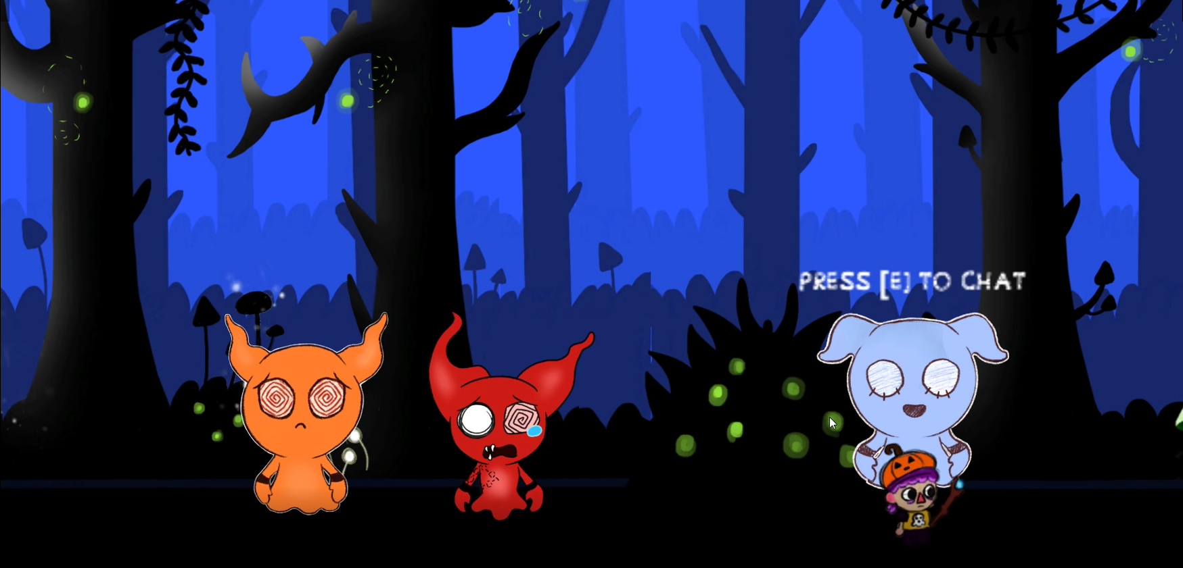
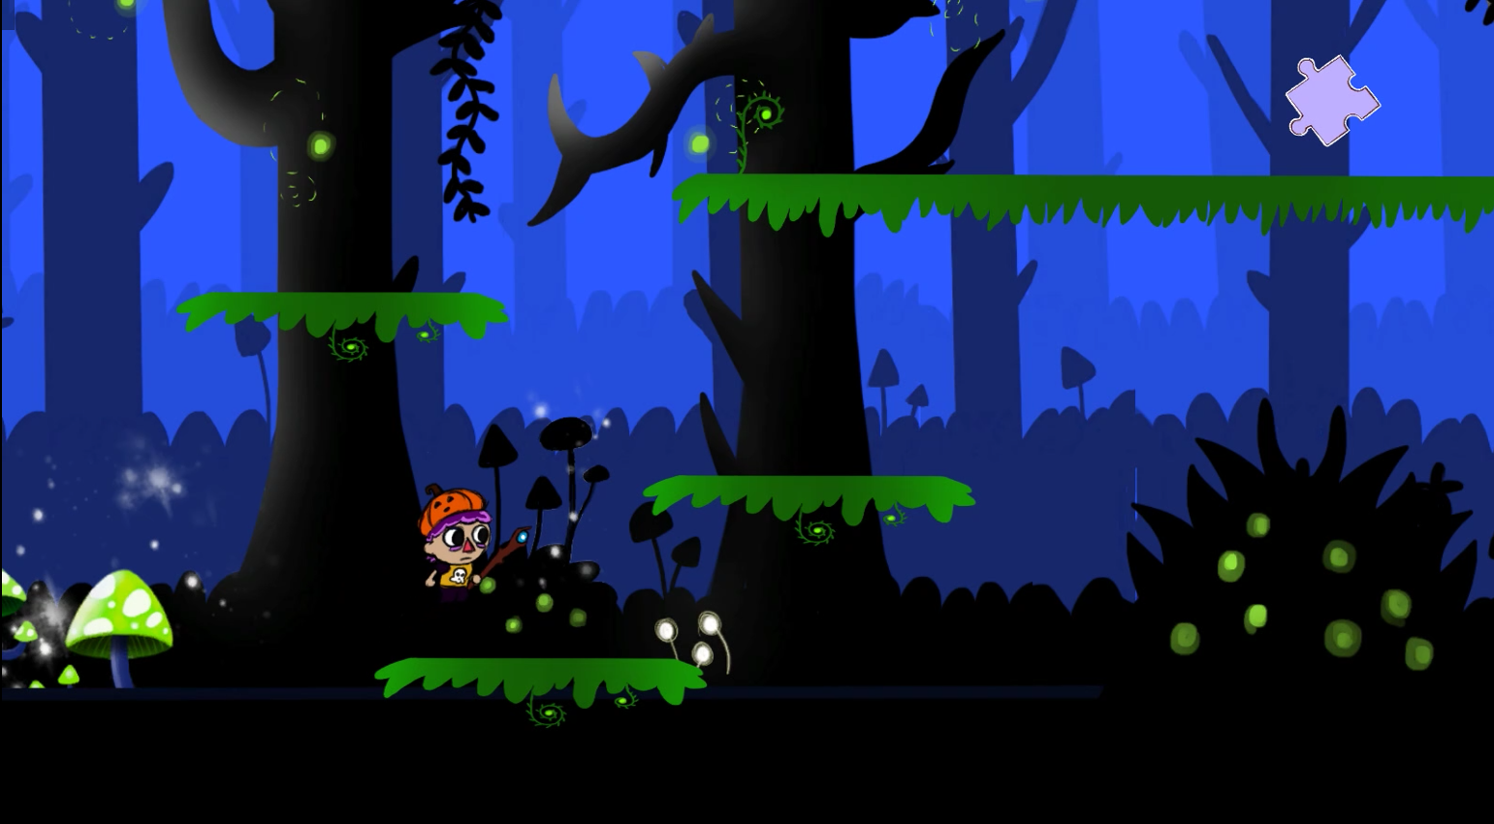
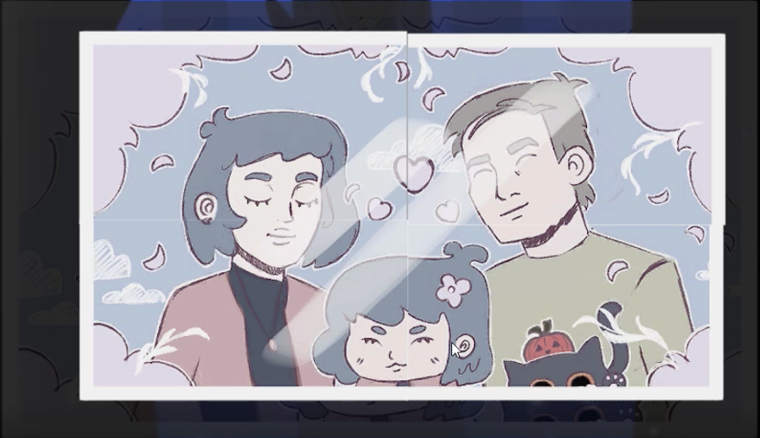
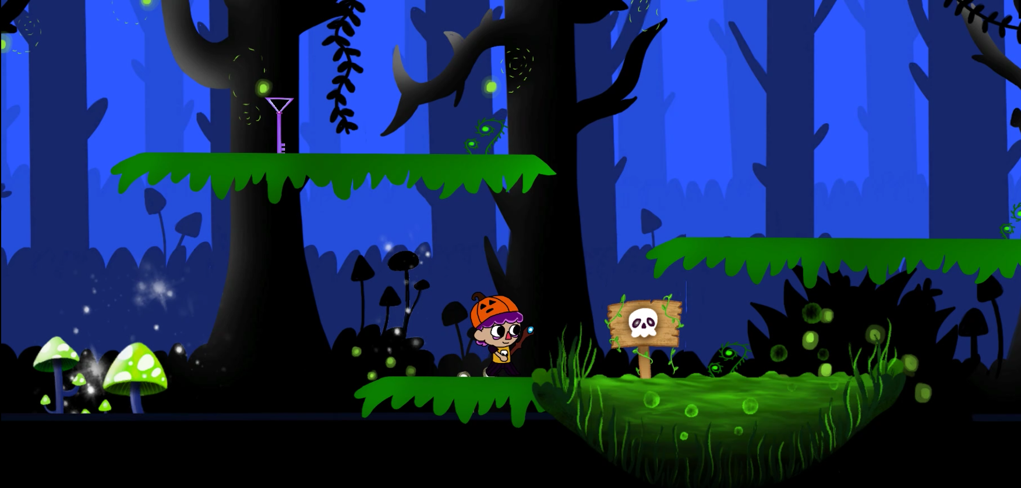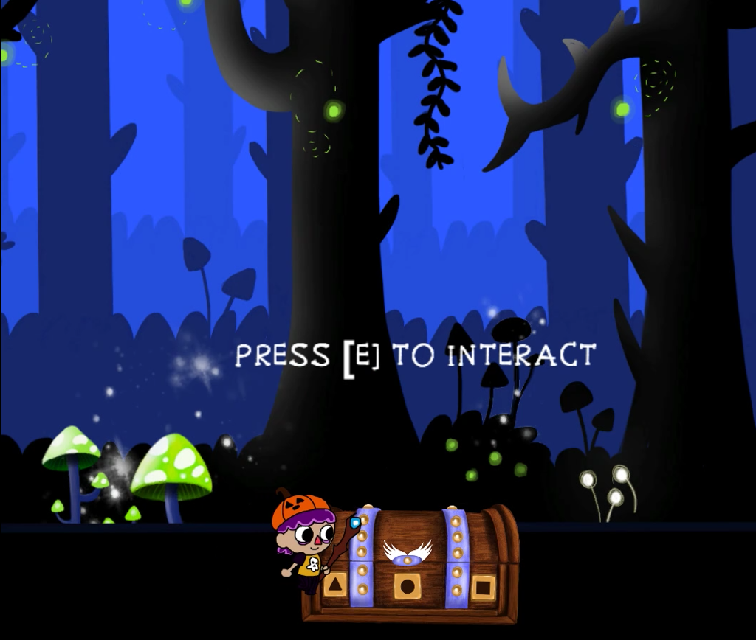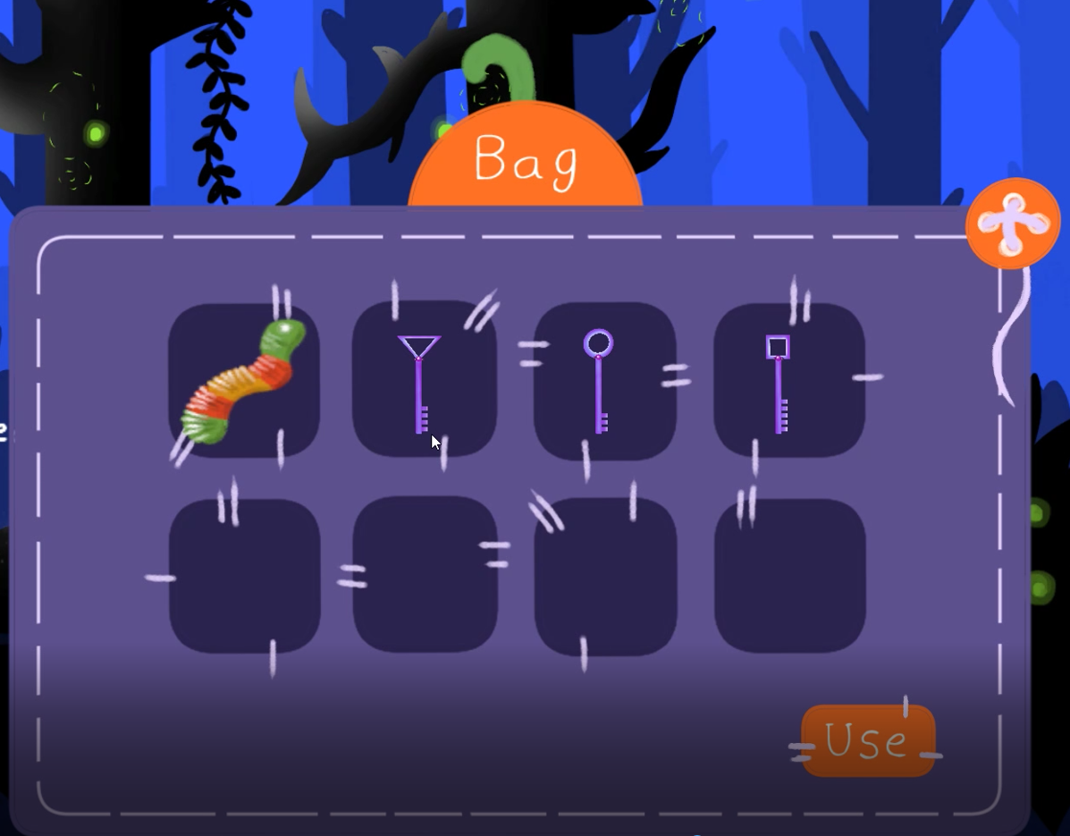

Screen Flow
There are three levels/puzzles, starting from blue, to orange and to red and leading to the black which leads to the combat. To reach a new ghost, one must finish the first one. Finish tasks of each puzzle to move to the next in steps. Adding the parallex effect, the dynamic background keeps changing colours with respect to the difficulty of the ghosts, the blue represents the calm and soothing feel, the red represents danger, this leads to the purple background in transition. Images shown below:

Game Options
The options in the game are minimal as the player choose to play, quit, or go to the setting option to turn on/off the audio. The quit function leaves the game, and the play function takes the player to the opening scene with the moss’s background story and leading him to the forest. After this the player can exit the game through the ESC button.

Replay-ability
The game is replay-able as every time the player loses or game over, it restarts the same puzzle and hence the player does not need to start over from beginning and give them multiple chances to try different things.

Story, Setting and Characters

Story and Narrative

Story Synopsis:
Moss comes from a family of ghost hunters/mediums and after his parents’ death, he become a medium to honor their memory. Moss helps ghosts to finish/solve their problems/tasks so they can move to the afterlife.
Moss suddenly stumbles upon a blue light in the forest and moves closer for a better look. He finds something spooky.
When moss approaches the ghost, he communicates with them, solve their tasks and move forward.

Narrative Structure to players:
- Character is roaming in forest
- Stumbles upon a ghost and approaches them
- Through communication, finds out their problem
- Finish their task in a form of puzzle
- Get reward items (charms)
- Move to the next ghost while helping them pass through
- Black Ghost involves a fight via shooting projectiles

Levels

Levels (Blue, orange, red and black)
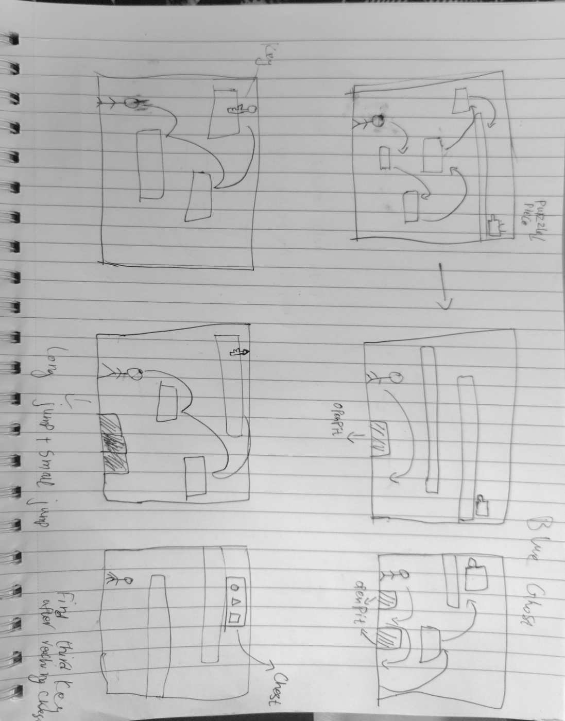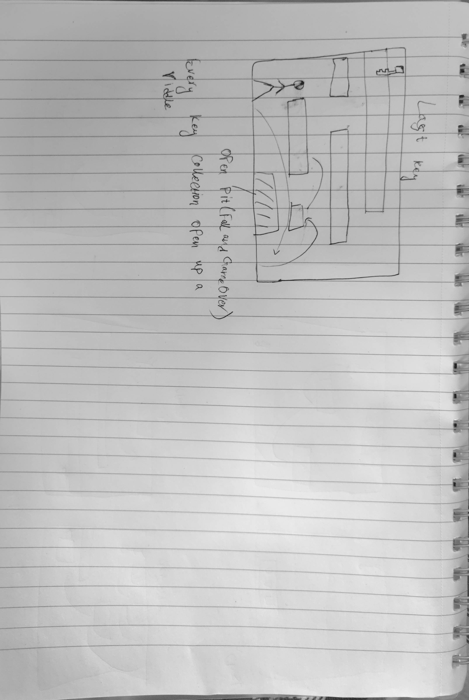
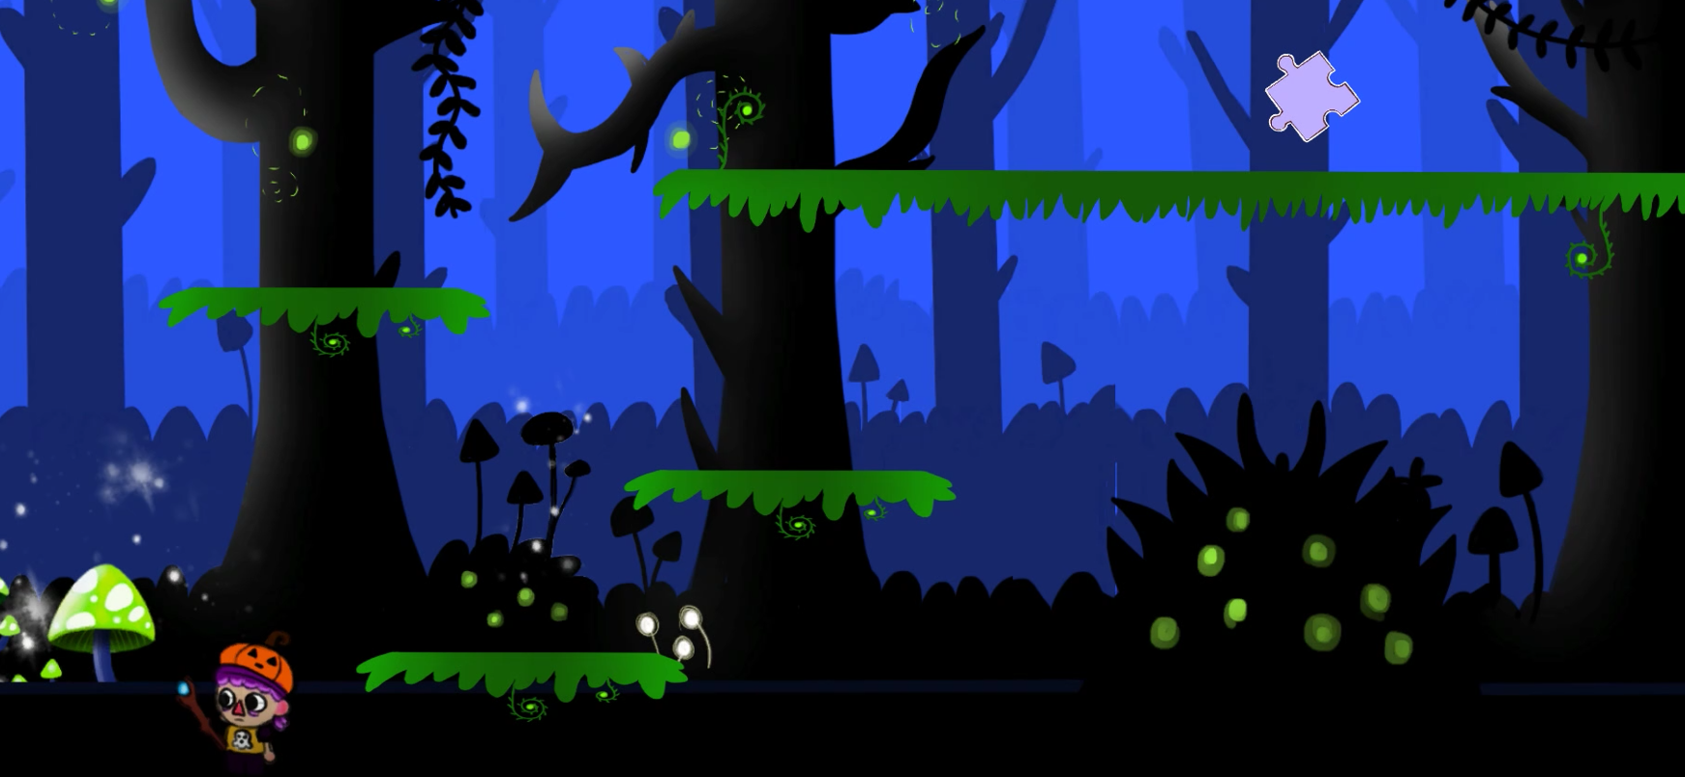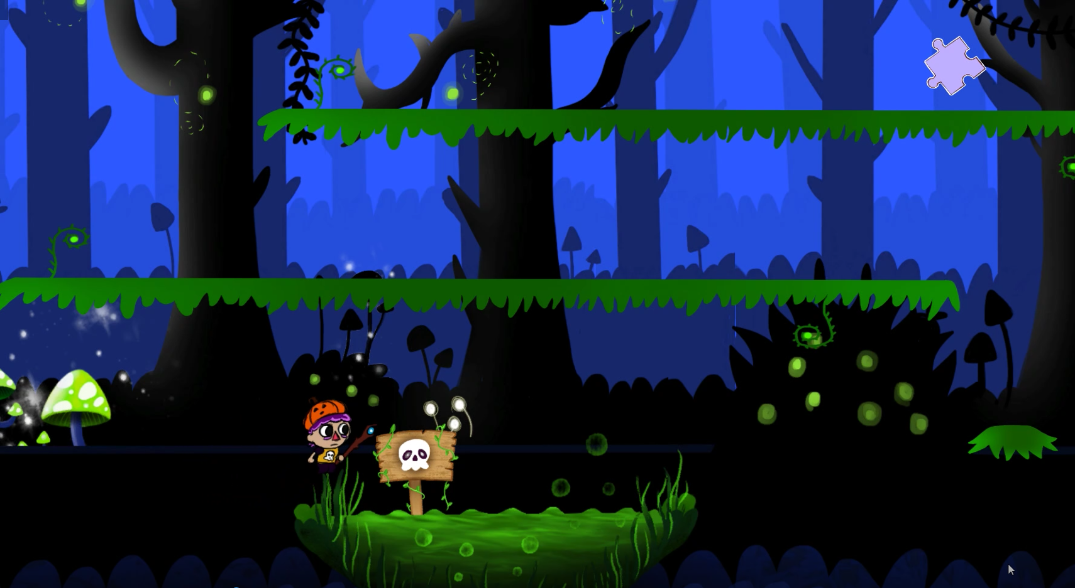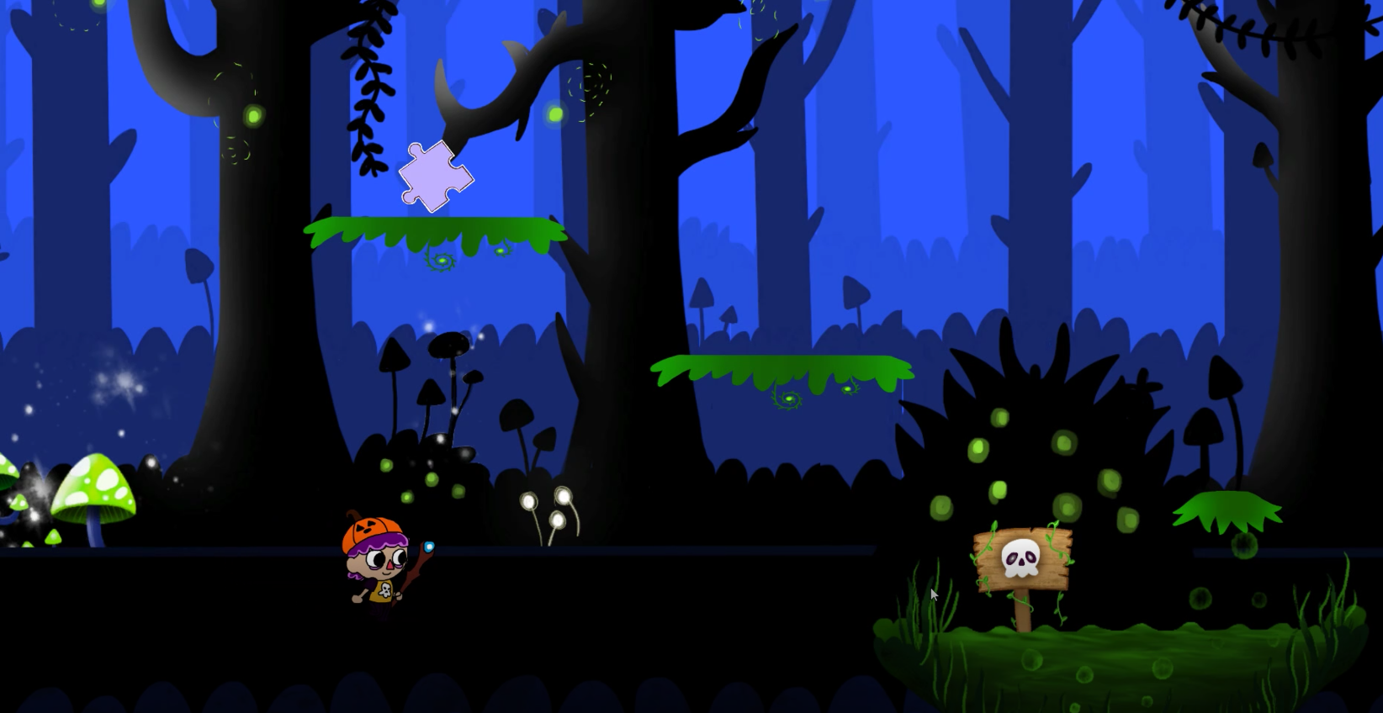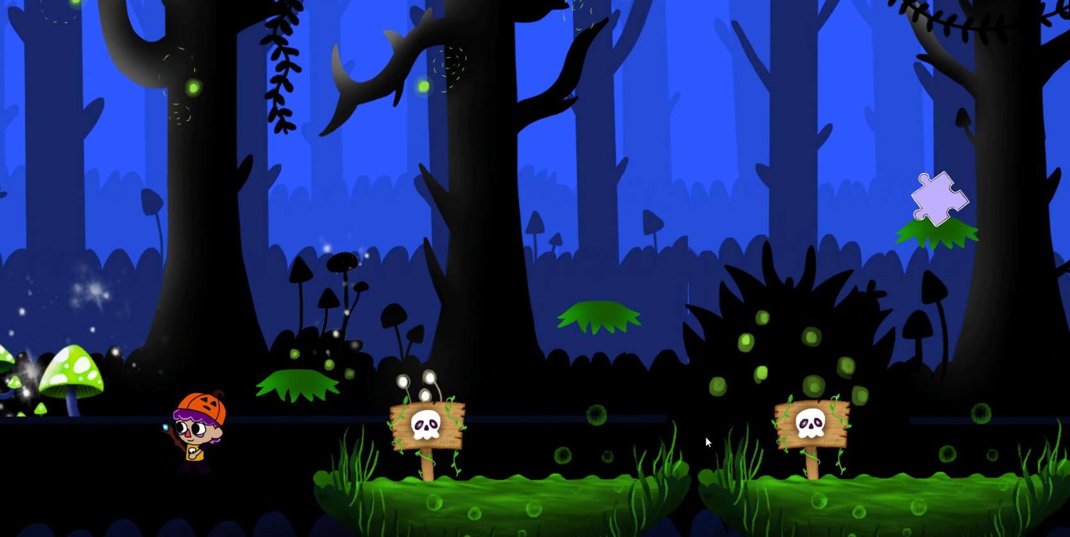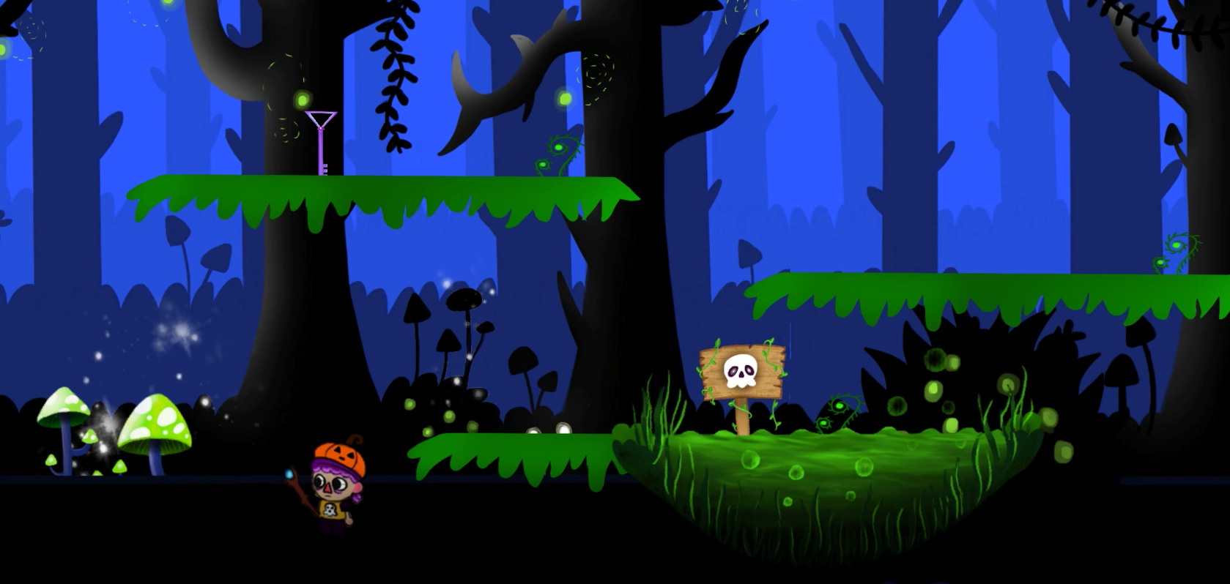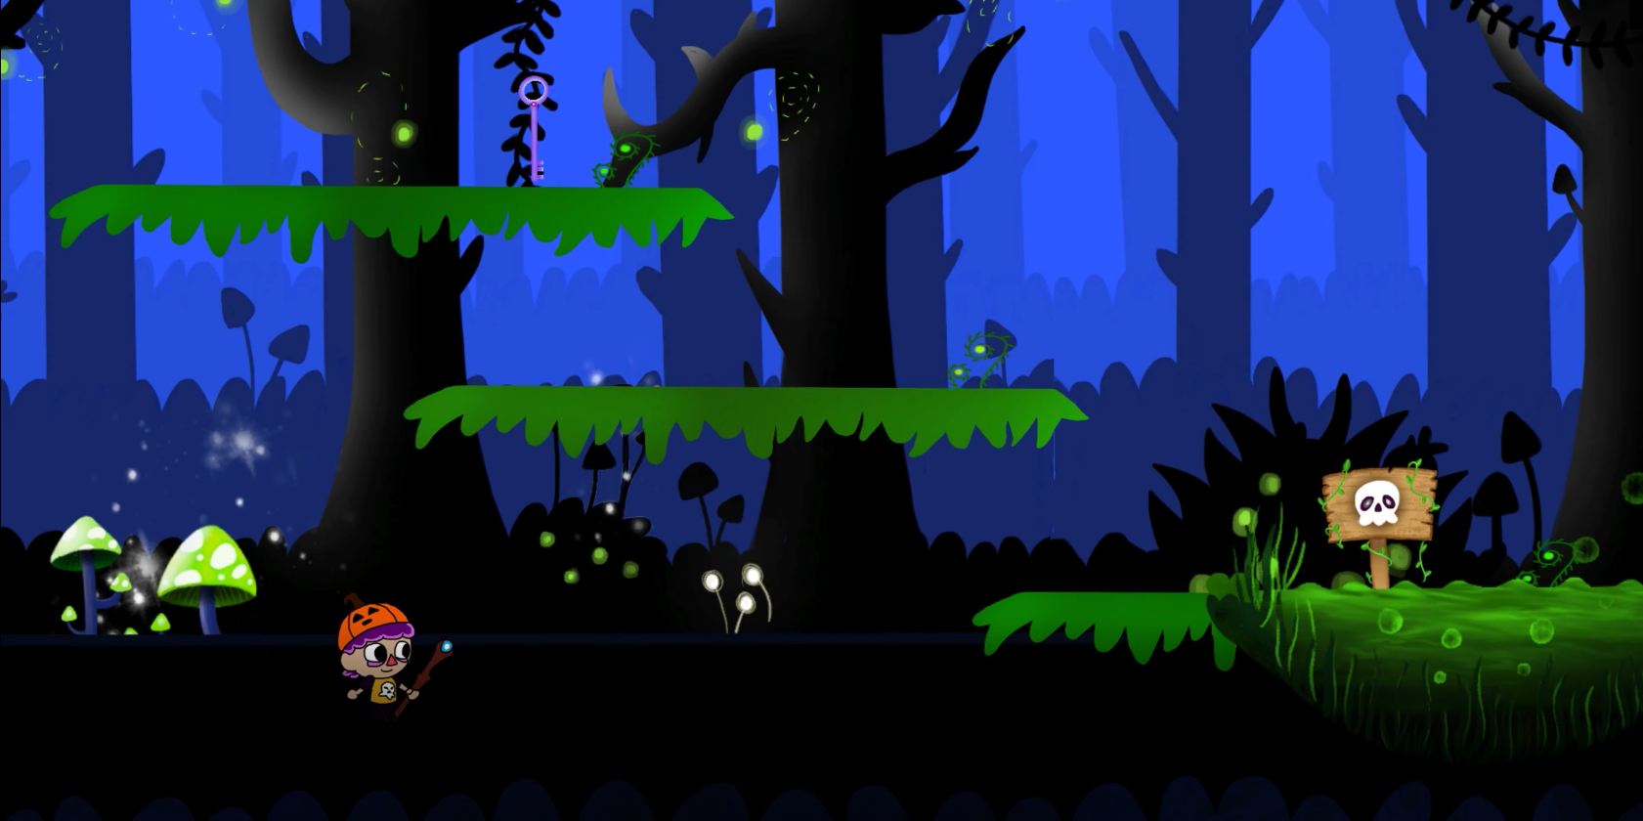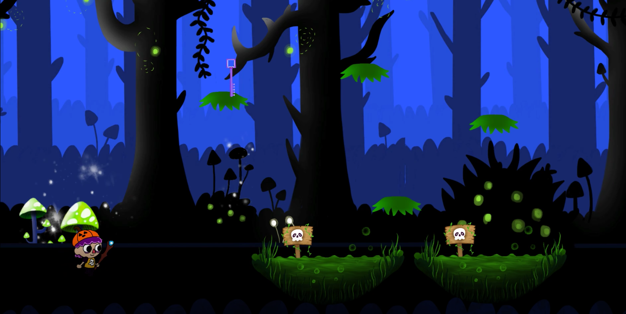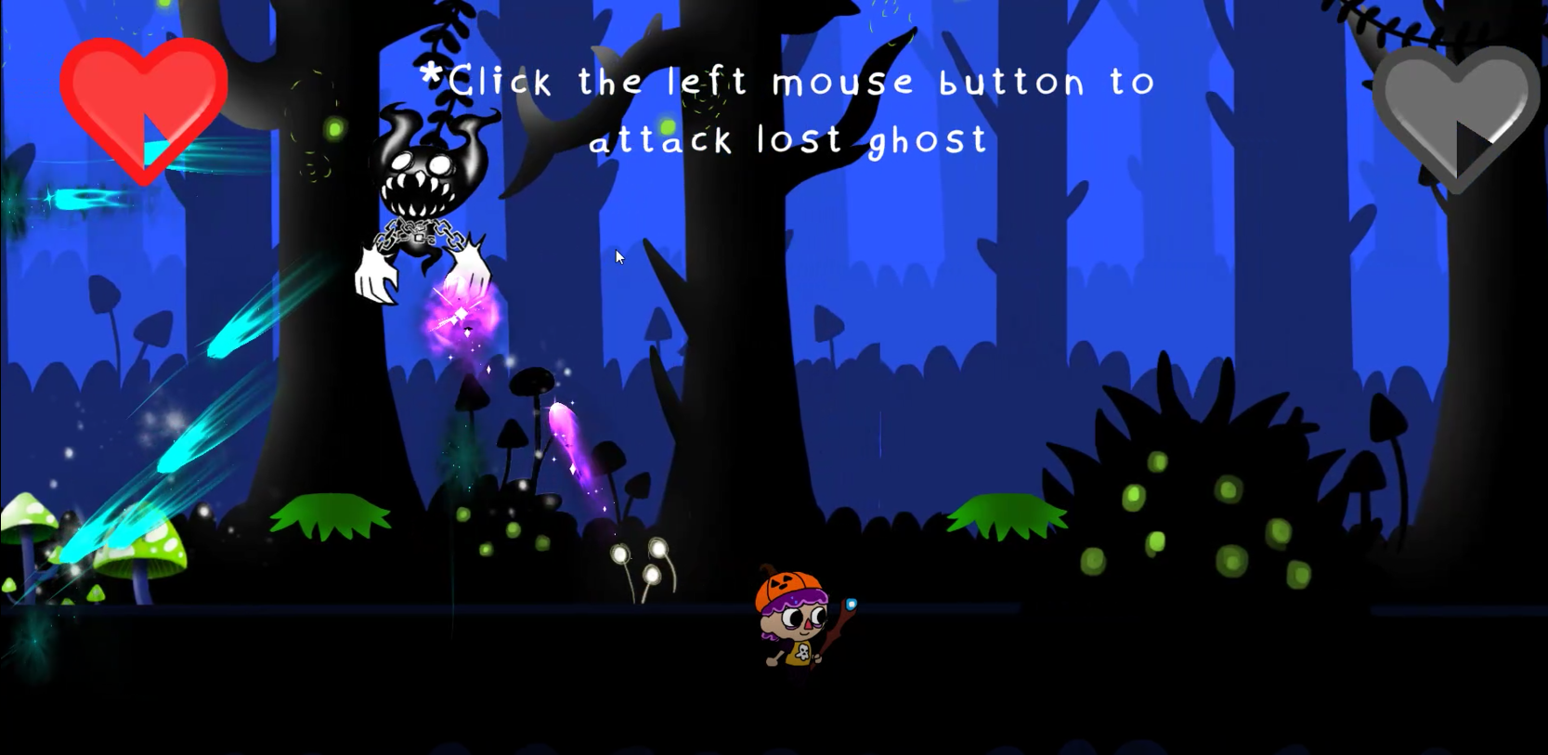

Interface

Visual System
Camera: The camera is static. As such as it displays a whole level at any time.
Main Menu: Displays several options such as Start, setting, and quit.
End Screen: will give the player to return to the main menu or exit thus closing the game.

Control System
Moving – Press A to move left, D towards right.
Jumping – Press the space bar once to jump, in continuous pressing, press twice, for double jump.
Shooting Projectiles – Press mouse left click to shoot projectile at the ghost.
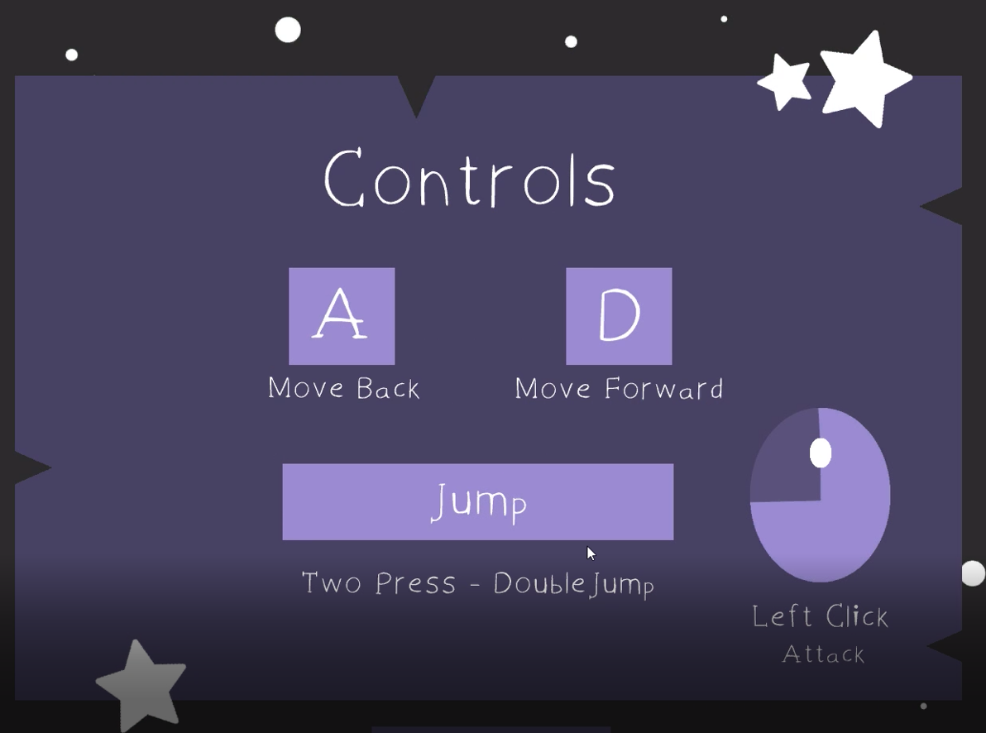

Audio, music and sound effects
Background music will try to reflect the tone of the level which is determined by the level of ghost.
Sound effects will be used to give audible feedback on all player and environmental actions.

Credits
Background Music by Darren Curtis – I’m not What I thought.
Sound Effects by Alan Mckinney, obtained from https://www.zapslat.com
All animations of character and ghosts by Nihlus.
Programming material of ghosts, main menu, player controller by Xinshuang (Chalos) and Ari.
Character artwork, ghost sketches, concept art by Shauna, Daisy and Nihlus.
UI/UX as well as main menu/ options menu by Shauna.
Video trailer/promo by Ari.
Audio design, game design, gameplay elements including puzzles.
QA testing and bug finding by Daisy and Areez.
Narrative story writing by Shauna, Daisy, Nihlus and Areez.

4 types of ghosts

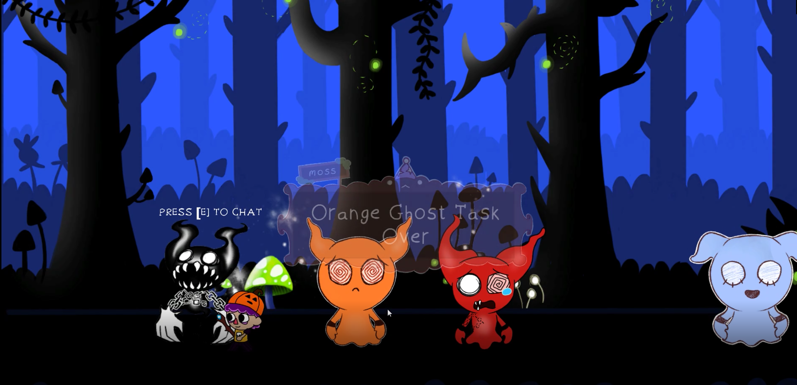

Task Distribution
A Trello group was created that would keep all the tasks of the team in one side whilst each member can review their tasks and the timeline they adhere to. A google drive folder was also created to upload all the documents, code, game files, character sketches, final artwork, UI/UX, trailer as Trello free version does not allow users to upload bigger files.
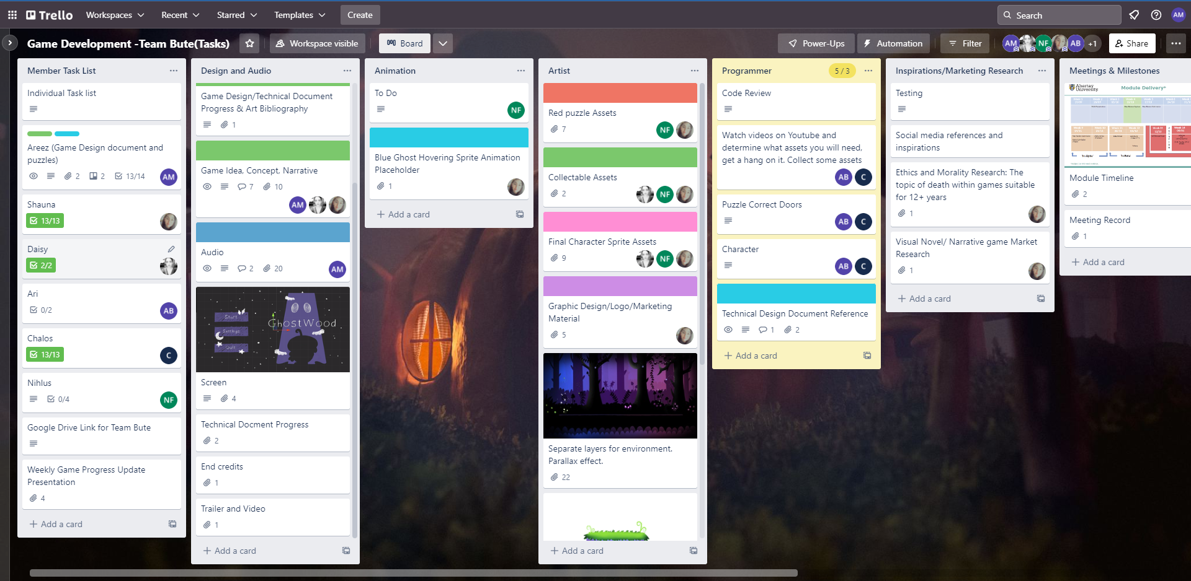

Bibliography
Gee, J. (n.d.). [online] Academiccolab.org. Available at: http://www.academiccolab.org/resources/documents/Good_Learning.pdf [Accessed 07 Nov. 2022].
Curtis, D. 2019. Darren Curtis Music. [Sound recording]. [Accessed 07 November 2022]. Available from: https://www.darrencurtismusic.com/freemusicpage3
Mckinney, A. 2015. Free Sound Effects. [Sound recording]. [Accessed 04 November 2022]. Available from: https://www.zapslat.com

